**Group-5 Bug-4**

1. **Failing Test name**

Data cache Write Miss Test

1. **Test description (Describe the planned scenario and the expected result)**

write_miss_dcache: A basic write on the data cache was executed, resulting in a miss, and was expected to get data from level-2 cache. This was done on all CPUs to ensure full coverage.

1. **Failing assertion that helped you identify the bug**

Error message:

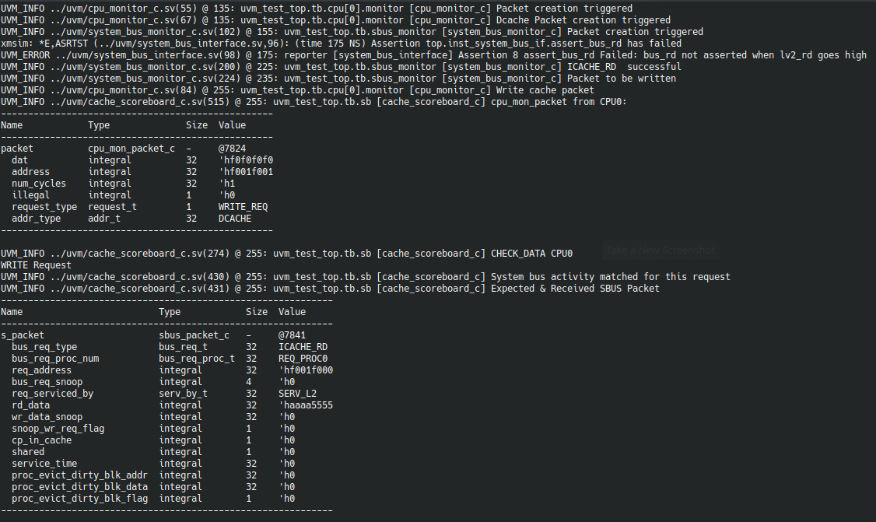

1. **Debug Process**

It was found that neither bus_rd nor bus_rdx was being asserted on a lv2_rd. Since this is a write test and since read tests had satisfied this assertion previously, we expect bus_rdx to be asserted in this case.

To check why, the design file was searched for assignment to bus_rdx, and an error was found.

1. **Erroneous RTL file name**

main_func_lv1_dl.sv

1. **Lines of RTL file responsible for the bug (mention the line numbers and lines of the bug)**

248. bus_rdx_reg <= 1'bz;

1. **Corrected RTL code (only mention the corrections)**

248. bus_rdx_reg <= 1'b1;